**Help us help a woman with PGP and raise funds for the Pelvic Partnership**

The Pelvic Partnership is a small charity offering support and information to women experiencing pregnancy-related pelvic girdle pain (PGP).

PGP affects around one in five women during pregnancy or postnatally, causing pain, immobility and associated mental health impacts. We work with healthcare practitioners to raise awareness about PGP and how it can be safely and effectively treated with hands-on manual therapy, such as physiotherapy, osteopathy or chiropractic care.

We offer support and information to women with PGP, their families and carers through our telephone helpline, Facebook support group and social media channels. We also have an informative website, a list of recommended practitioners and a free downloadable ebook sharing practical suggestions on how to access manual therapy and manage your symptoms of PGP.

We rely solely on the generosity of our supporters to keep providing support and information to women with PGP, giving them the tools and confidence to access treatment for their PGP.

Thank you for supporting our charity.

**Fundraise for us!**

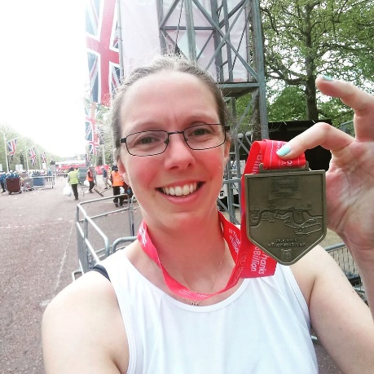

You can organise any kind of event or challenge to raise funds for the Pelvic Partnership – the more usual, the more popular they may become!

Why not?

* Do a virtual couch to 5k or local trek
* Participate in a 10k run or half marathon
* Charity raffle
* Cake sale

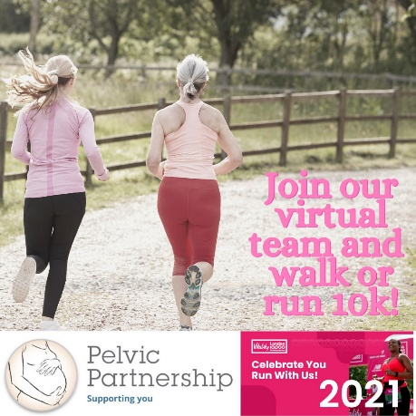

Or you could run a fundraising event, either in person or a virtual event over Zoom, such as:

* A crafternoon
* A fashion show
* A quiz night
* A baby shower

You could also do a Facebook fundraiser to celebrate your birthday - encourage friends and family to donate to the Pelvic Partnership as a birthday gift to you at [**www.facebook.com/fund/PelvicPartnership/**](http://www.facebook.com/fund/PelvicPartnership/)!

**Set up an online fundraiser**

The easiest way for you to start fundraising for the Pelvic Partnership is to set up an online fundraiser using an online platform, such as LocalGiving, Wonderful.org or via Facebook.

These tools also enable you to apply for Gift Aid from the UK Government. All UK taxpayers can give permission for the Pelvic Partnership to reclaim tax on your donation, i.e. they can reclaim 25p of tax on every £1 donated.

[](https://www.facebook.com/fund/PelvicPartnership/)[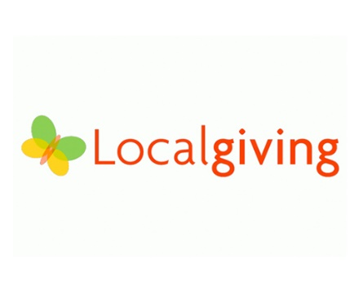](http://www.localgiving.org/charity/pelvic-partnership/)

[](http://www.wonderful.org/charities/1100373)

Click on the logos above or the links below:

* [**www.localgiving.org/charity/pelvic-partnership/**](http://www.localgiving.org/charity/pelvic-partnership/)
* [**www.wonderful.org/charities/1100373**](http://www.wonderful.org/charities/1100373)
* [**www.facebook.com/fund/PelvicPartnership/**](http://www.facebook.com/fund/PelvicPartnership/)

**Sponsorship form**

You can also encourage people to donate in cash and complete the sponsorship form overleaf. Please then transfer any donations to the Pelvic Partnership.

**Thank you for your support**

Thank you so much for supporting the Pelvic Partnership.

To discuss any fundraising ideas, please contact our co-ordinator at [contact@pelvicpartnership.org.uk](mailto:contact@pelvicpartnership.org.uk).

We would love to share your efforts on our social media channels! Please share your fundraiser on social media tagging the Pelvic Partnership and #pgpistreatable.

**Please sponsor me (name of participant) _____________________________________________________________________________**

**To (name of event) _______________________________________________________________________________________________**

**In aid of the Pelvic Partnership, a national charity offering support and information to women experiencing pregnancy-related pelvic girdle pain (PGP).**

If I have ticked the box headed “Gift Aid?” I confirm that I am a UK Income or Capital Gains taxpayer. I have read this statement and want the Pelvic Partnership to reclaim tax on the donation detailed above, given on the date shown. I understand that if I pay less Income Tax/or Capital Gains Tax in the current tax year than the amount of Gift Aid claimed on all of my donations it is my responsibility to pay any difference. I understand the Pelvic Partnership will reclaim 25p of tax on every £1 that I have given.

**Remember: You must provide your full name, homes address, postcode and & ✓ Gift Aid for the Pelvic Partnership to claim tax back on your donation.**

|  |  |  |  |  |  |  |
| --- | --- | --- | --- | --- | --- | --- |
|  | **Sponsor’s Full Name**  *First Name and Surname* | **Sponsor’s Home Address**  *Only needed if you are Gift Aiding your donation.*  *Don’t give your work address if you are Gift Aiding your donation.* | **Postcode** | **Donation Amount**  £ | **Date Paid** | **Gift Aid? ✓** |
| 1 |  |  |  |  |  |  |
| 2 |  |  |  |  |  |  |
| 3 |  |  |  |  |  |  |
| 4 |  |  |  |  |  |  |
| 5 |  |  |  |  |  |  |
| 6 |  |  |  |  |  |  |
| 7 |  |  |  |  |  |  |
| 8 |  |  |  |  |  |  |
| 9 |  |  |  |  |  |  |
|  |  | **Total donations received** | **£** | | | |
|  |  | **Total Gift Aid donations** | **£** | | | |
|  |  | **Date donations given to the Pelvic Partnership** |  | | | |